**Md Reza**

**HW4:** Tableau Exercise

**Due Date:** 11-16-2019

**DSA6000** – Fall 2019

**Dashboard Highlights:**

* Changed the “Height” & “Weight” to number data type
* Changed the “Region” & “Team” to “Geographic Role – Country/Region” type
* Leveraged Mapbox Style API for Map background
* Removed some NULL values for improving the accuracy
* Analyzed how the Olympics have evolved over time
* Analyzed correlations among participation, performance, nations, and sports

**Dashboard Contents:**

**Map –** Filter and visualize medal counts by region: It seems USA has the highest medal counts

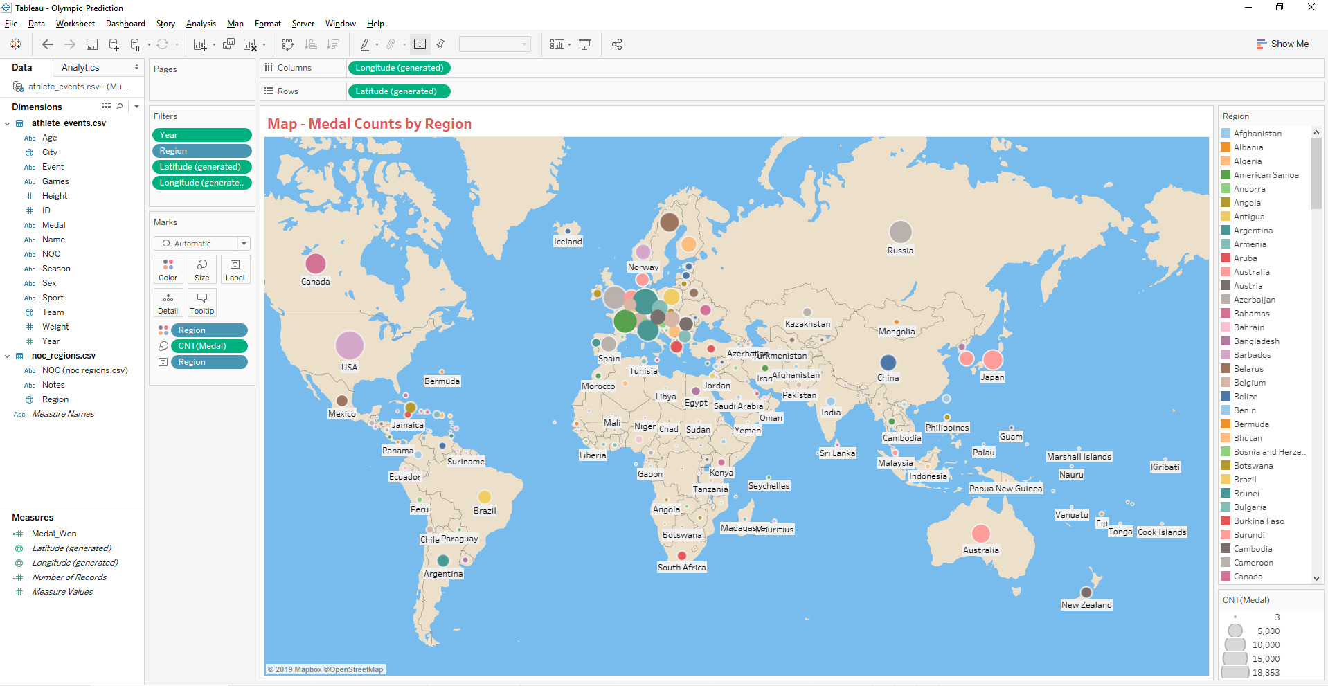

**Map –** Filter and visualize regional geofence with medal counts

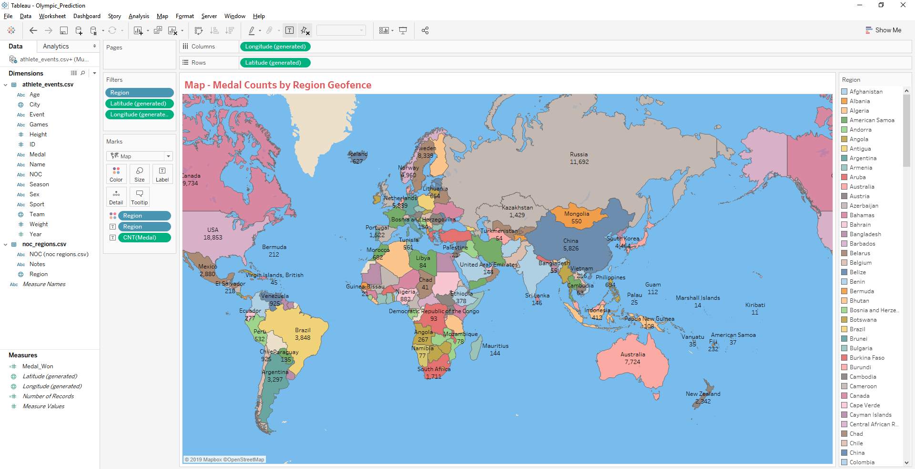

**Bar Chart -** Medal Category count by Region: Again, USA has the highest counts in all category i.e. Bronze, Gold, and Silver followed by Russia & Germany.

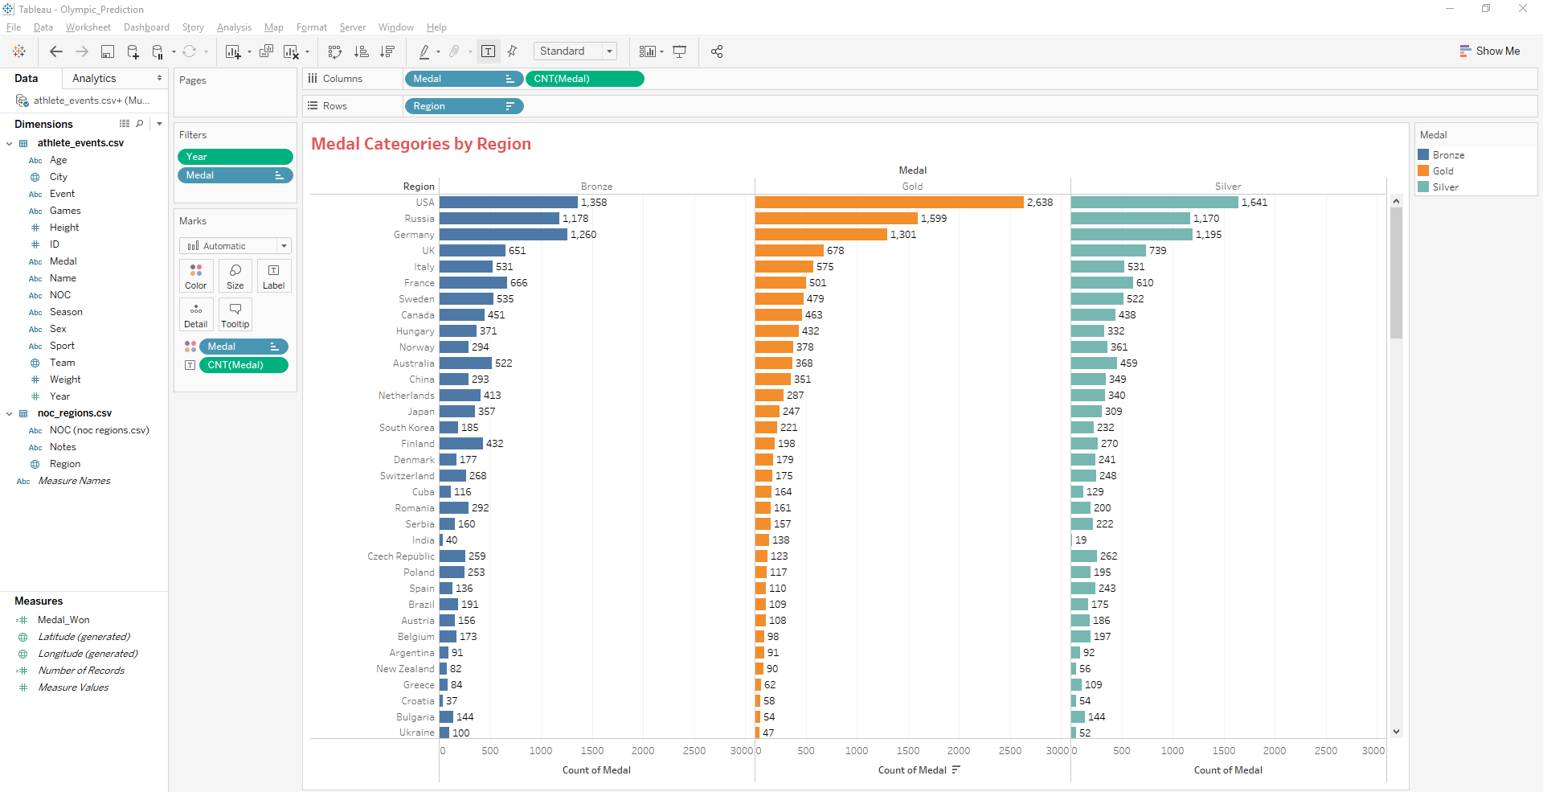

**Bar chart** & **Line chart** for visualizing top sports: “Athletics” has the highest counts followed by “Gymnastic” and “Swimming”.

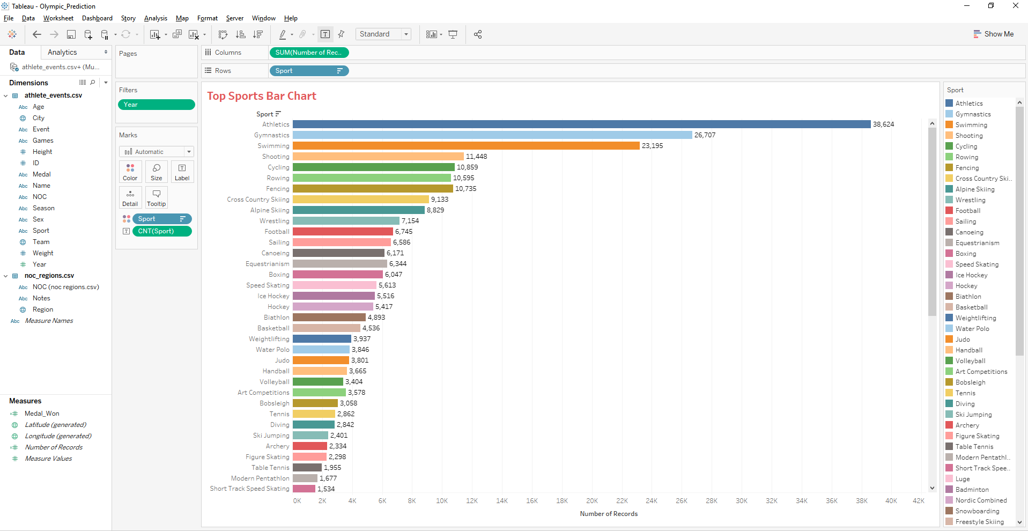

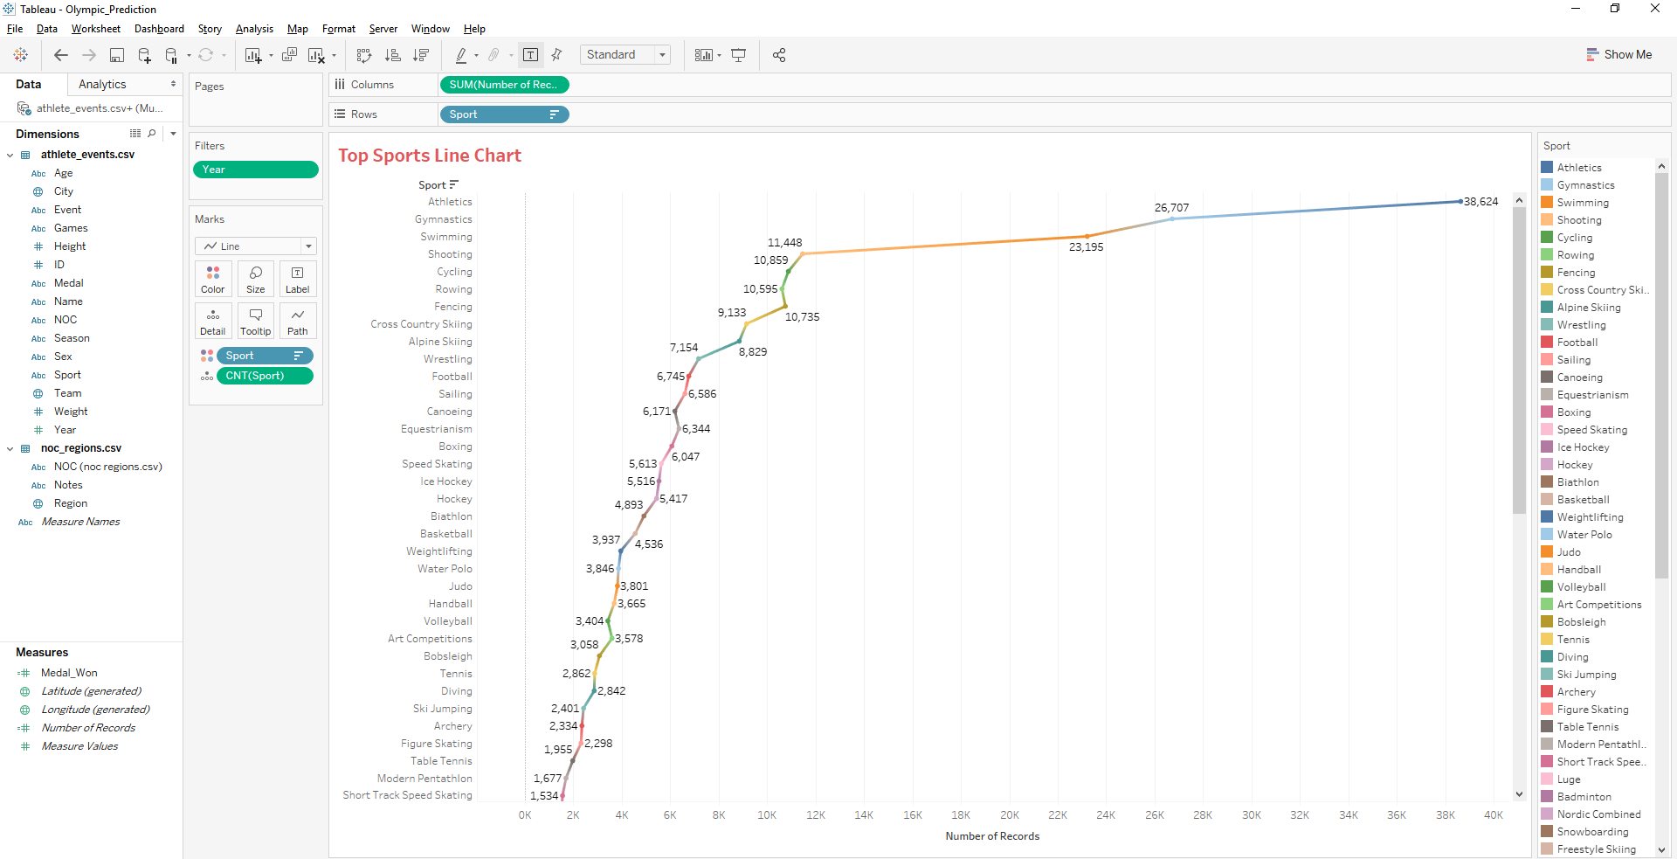

It seems that we have people with Age greater than 50 with gold medal & people with Age range from 23 - 24 has the highest medal counts in all medal type.

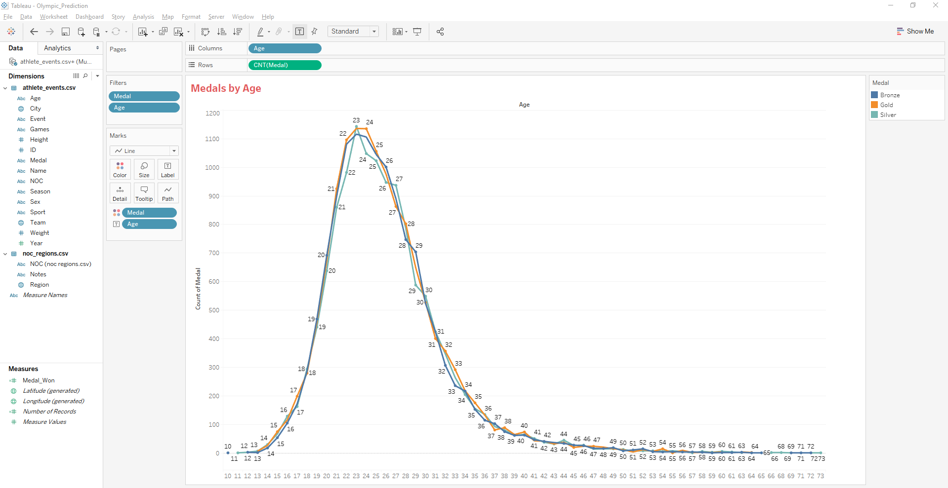

Medal splits by sports and medal type

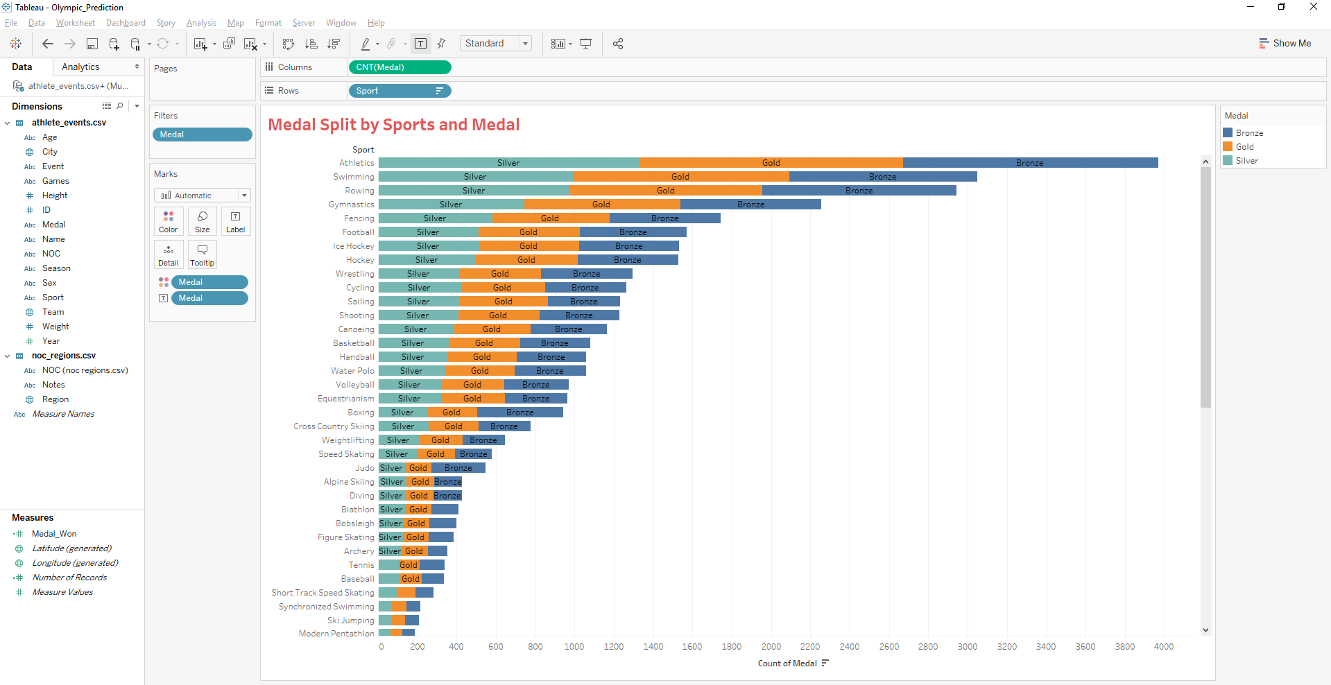

Medal counts timeline

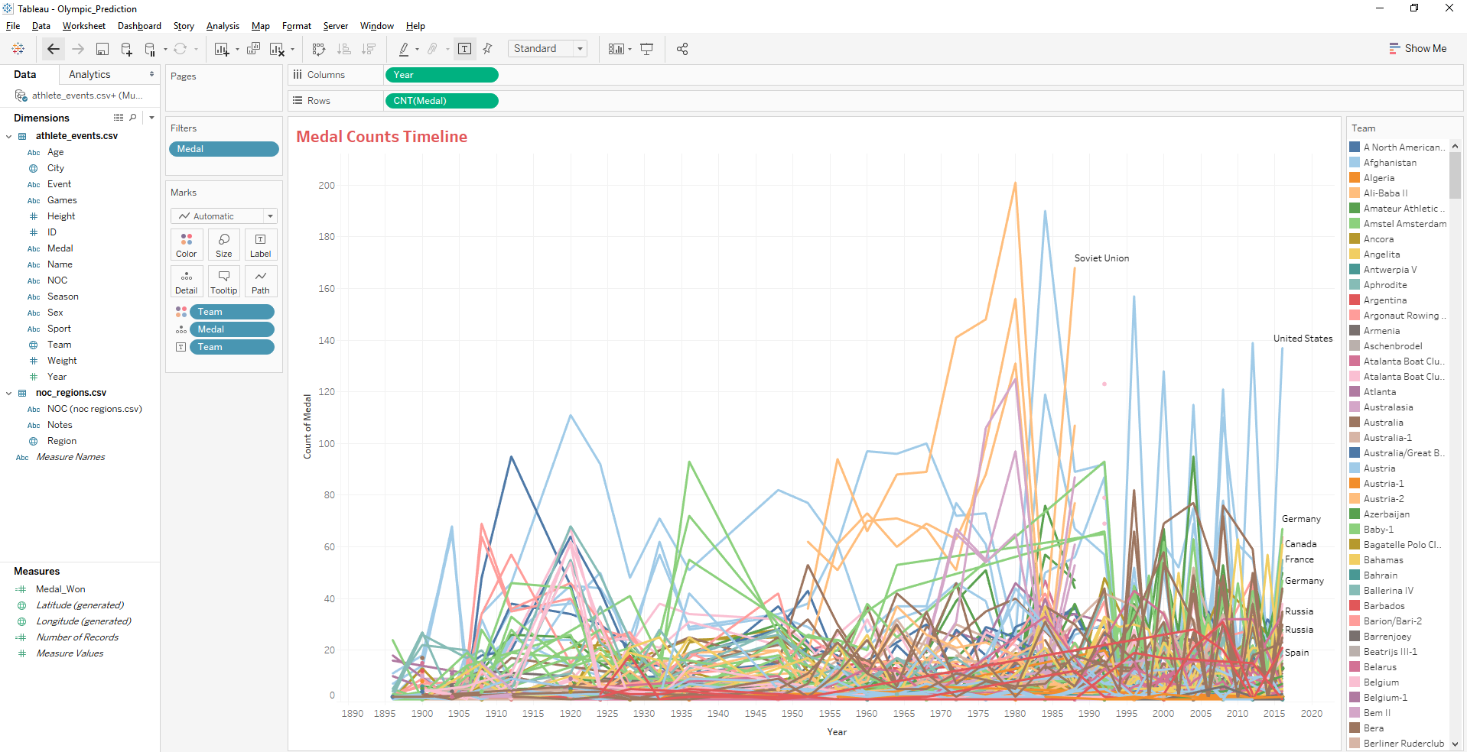

Finally, the following line chart shows there is a correlation between high height and high medal counts.

